Dimensional Analysis
# Source: AI Source: Provided by: [Data Path: Persons Table -> ID Column: 1, Name_En Column: Motasem Essam] -> From: [ChatGPT] on [7/17/2026]
Dimensional Analysis is a mathematical technique used to analyze the dimensions of physical quantities in equations and calculations. It verifies that equations are dimensionally consistent, derives relationships between variables, performs unit conversions, and helps detect errors in scientific and engineering calculations.
Unlike Unit Analysis, which works with actual measurement units (such as meters or kilograms), dimensional analysis works with the fundamental dimensions of physical quantities, such as Length (L), Mass (M), Time (T), Electric Current (I), Temperature (Θ), Amount of Substance (N), and Luminous Intensity (J).

Definition
# Source: AI Source: Provided by: [Data Path: Persons Table -> ID Column: 1, Name_En Column: Motasem Essam] -> From: [ChatGPT] on [7/17/2026]
Dimensional Analysis is the process of representing physical quantities by their fundamental dimensions and using those dimensions to verify equations, derive formulas, and analyze physical relationships.

Purpose
# Source: AI Source: Provided by: [Data Path: Persons Table -> ID Column: 1, Name_En Column: Motasem Essam] -> From: [ChatGPT] on [7/17/2026]
Dimensional analysis is used to:
- Verify that physical equations are dimensionally correct.
- Detect errors in formulas.
- Derive relationships between physical quantities.
- Simplify scientific calculations.
- Perform dimensional reasoning.
- Support unit conversion and scaling.

Characteristics
# Source: AI Source: Provided by: [Data Path: Persons Table -> ID Column: 1, Name_En Column: Motasem Essam] -> From: [ChatGPT] on [7/17/2026]
Dimensional analysis:
- Uses dimensions, not numerical values.
- Ignores numerical constants.
- Checks dimensional consistency.
- Represents quantities using powers of fundamental dimensions.
- Cannot determine numerical coefficients in equations.

Fundamental Dimensions
# Source: AI Source: Provided by: [Data Path: Persons Table -> ID Column: 1, Name_En Column: Motasem Essam] -> From: [ChatGPT] on [7/17/2026]
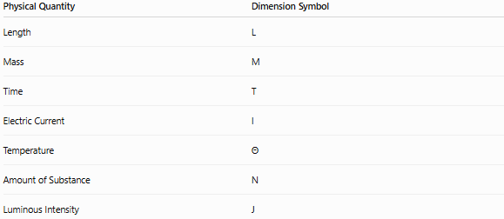
Physical Quantity | Dimension Symbol
Length | L
Mass | M
Time | T
Electric Current | I
Temperature | Θ
Amount of Substance | N
Luminous Intensity | J

Derived Dimensions
# Source: AI Source: Provided by: [Data Path: Persons Table -> ID Column: 1, Name_En Column: Motasem Essam] -> From: [ChatGPT] on [7/17/2026]
Many physical quantities are combinations of the fundamental dimensions.
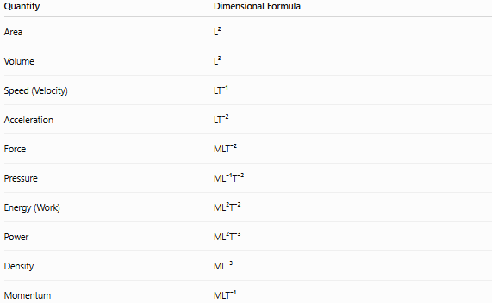
Quantity | Dimensional Formula
Area | L²
Volume | L³
Speed (Velocity) | LT⁻¹
Acceleration | LT⁻²
Force | MLT⁻²
Pressure | ML⁻¹T⁻²
Energy (Work) | ML²T⁻²
Power | ML²T⁻³
Density | ML⁻³
Momentum | MLT⁻¹

Dimensional Formula
# Source: AI Source: Provided by: [Data Path: Persons Table -> ID Column: 1, Name_En Column: Motasem Essam] -> From: [ChatGPT] on [7/17/2026]
A dimensional formula expresses a physical quantity in terms of the powers of the fundamental dimensions.
Examples:
Distance
$$\left[L\right]$$

Area
$$\left[L^{2}\right]$$

Volume
$$\left[L^{3}\right]$$

Speed
$$\left[LT^{-1}\right]$$

Acceleration
$$\left[LT^{-2}\right]$$

Force
Using
Force = Mass × Acceleration
$$\left[M][LT^{-2}]=[MLT^{-2}\right]$$

Pressure
Using
Pressure = Force / Area
$$\frac{MLT^{-2}}{L^{2}}=ML^{-1}T^{-2}$$

Density
Using
Density = Mass / Volume
$$\frac{M}{L^{3}}=ML^{-3}$$

Principle of Dimensional Homogeneity
# Source: AI Source: Provided by: [Data Path: Persons Table -> ID Column: 1, Name_En Column: Motasem Essam] -> From: [ChatGPT] on [7/17/2026]
A valid physical equation must have the same dimensions on both sides.
Example:
Distance = Speed × Time
Left side:
$$\left[L\right]$$
Right side:
$$\left[LT^{-1}][T]=[L\right]$$
Both sides have dimension L, so the equation is dimensionally correct.

Examples
# Source: AI Source: Provided by: [Data Path: Persons Table -> ID Column: 1, Name_En Column: Motasem Essam] -> From: [ChatGPT] on [7/17/2026]
Example 1 – Verify Force Equation
Given:
Force = Mass × Acceleration
Dimensions:
Left:
$$F=MLT^{-2}$$
Right:
$$M×LT^{-2}=MLT^{-2}$$
Dimensions match.

Example 2 – Verify Energy Equation
Energy = Force × Distance
Dimensions:
$$MLT^{-2}×L=ML^{2}T^{-2}$$
Correct.

Example 3 – Verify Power Equation
Power = Energy / Time
Dimensions:
$$\frac{ML^{2}T^{-2}}{T}=ML^{2}T^{-3}$$
Correct.

Uses of Dimensional Analysis
# Source: AI Source: Provided by: [Data Path: Persons Table -> ID Column: 1, Name_En Column: Motasem Essam] -> From: [ChatGPT] on [7/17/2026]
1. Checking Equations
Verifies that equations are physically meaningful.

2. Deriving Relationships
Helps determine how variables are related.
Example:
Pendulum period depends on:
- Length
- Gravity
Dimensional analysis helps determine the general relationship before experimentation.

3. Unit Conversion
Supports conversion between compatible unit systems.

4. Error Detection
Identifies equations that cannot be physically correct.

Advantages
# Source: AI Source: Provided by: [Data Path: Persons Table -> ID Column: 1, Name_En Column: Motasem Essam] -> From: [ChatGPT] on [7/17/2026]
Dimensional analysis:
- Detects incorrect equations.
- Simplifies derivations.
- Reduces calculation errors.
- Supports scientific reasoning.
- Requires only dimension symbols.

Limitations
# Source: AI Source: Provided by: [Data Path: Persons Table -> ID Column: 1, Name_En Column: Motasem Essam] -> From: [ChatGPT] on [7/17/2026]
Dimensional analysis cannot:
- Determine numerical constants (such as 2, π, or ½).
- Distinguish quantities with identical dimensions.
Examples:
- Work and torque both have dimensions ML²T⁻², but they are different physical quantities.
- Determine whether an equation is scientifically complete if all dimensions happen to match.

Common Mistakes
# Source: AI Source: Provided by: [Data Path: Persons Table -> ID Column: 1, Name_En Column: Motasem Essam] -> From: [ChatGPT] on [7/17/2026]
- Confusing dimensions with units.
- Treating numerical constants as dimensions.
- Assuming dimensional correctness guarantees physical correctness.
- Ignoring derived dimensions.
- Forgetting exponent rules.

Dimensional Analysis vs. Unit Analysis
# Source: AI Source: Provided by: [Data Path: Persons Table -> ID Column: 1, Name_En Column: Motasem Essam] -> From: [ChatGPT] on [7/17/2026]
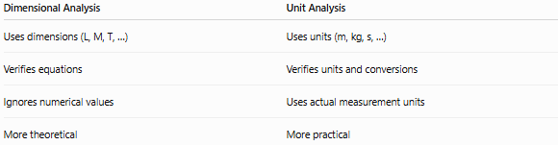
Dimensional Analysis | Unit Analysis
Uses dimensions (L, M, T, …) | Uses units (m, kg, s, …)
Verifies equations | Verifies units and conversions
Ignores numerical values | Uses actual measurement units
More theoretical | More practical

Applications
# Source: AI Source: Provided by: [Data Path: Persons Table -> ID Column: 1, Name_En Column: Motasem Essam] -> From: [ChatGPT] on [7/17/2026]
Dimensional analysis is widely used in:
- Physics
- Engineering
- Fluid mechanics
- Thermodynamics
- Electromagnetism
- Chemistry
- Aerospace engineering
- Mechanical engineering
- Scientific research
- Mathematical modeling

Key Points
# Source: AI Source: Provided by: [Data Path: Persons Table -> ID Column: 1, Name_En Column: Motasem Essam] -> From: [ChatGPT] on [7/17/2026]
- Dimensional Analysis represents quantities using fundamental dimensions.
- Every valid physical equation must satisfy the Principle of Dimensional Homogeneity.
- Common dimensions include:
  - L (Length)
  - M (Mass)
  - T (Time)
  - I (Electric Current)
  - Θ (Temperature)
  - N (Amount of Substance)
  - J (Luminous Intensity)
- It is used to verify equations, derive relationships, and detect errors.
- It complements Unit Analysis, which works with actual measurement units.

Conclusion
# Source: AI Source: Provided by: [Data Path: Persons Table -> ID Column: 1, Name_En Column: Motasem Essam] -> From: [ChatGPT] on [7/17/2026]
Dimensional Analysis is a powerful mathematical method for representing physical quantities in terms of their fundamental dimensions and ensuring that scientific and engineering equations are dimensionally consistent. By applying the Principle of Dimensional Homogeneity, it helps verify formulas, derive relationships between variables, identify errors, and support unit conversions. Although it cannot determine numerical constants or guarantee that an equation is physically complete, dimensional analysis remains an essential tool in physics, engineering, chemistry, mathematics, and scientific research for analyzing and validating physical relationships.

